Cryptography and Network Security Lab

Assignment 6  
Implementation and Understanding of Data Encryption Standard (DES) Cipher

2019BTECS00058  
Devang K

Batch: B2

Title: Implementation and Understanding of Data Encryption Standard (DES)

Aim: To Study, Implement and Demonstrate the Data Encryption Standard (DES)

* Part A- Implementation of DES using Virtual Lab
* Part B- Implementation of DES using C/C++/Java/Python or any other programming language

Theory:

The Data Encryption Standard is a symmetric-key algorithm for the encryption of digital data. Although its short key length of 56 bits makes it too insecure for modern applications, it has been highly influential in the advancement of cryptography.

The Data Encryption Standard (DES) is a symmetric-key block cipher published by the National Institute of Standards and Technology (NIST). DES is an implementation of a Feistel Cipher. It uses 16 round Feistel structure. The block size is 64-bit. Though, key length is 64-bit, DES has an effective key length of 56bits, since 8 of the 64 bits of the key are not used by the encryption algorithm.

DES is the archetypal block cipher—an algorithm that takes a fixed-length string of plaintext bits and transforms it through a series of complicated operations into another ciphertext bitstring of the same length. In the case of DES, the block size is 64 bits. DES also uses a key to customize the transformation, so that decryption can supposedly only be performed by those who know the particular key used to encrypt. The key ostensibly consists of 64 bits; however, only 56 of these are actually used by the algorithm. Eight bits are used solely for checking parity, and are thereafter discarded. Hence the effective key length is 56 bits. The key is nominally stored or transmitted as 8 bytes, each with odd parity.

One bit in each 8-bit byte of the KEY may be utilized for error detection in key generation, distribution, and storage. Bits 8, 16, ... , 64 are for use in ensuring that each byte is of odd parity. Like other block ciphers, DES by itself is not a secure means of encryption, but must instead be used in a mode of operation. FIPS-81 specifies several modes for use with DES. Further comments on the usage of DES are contained in FIPS-74.

Decryption uses the same structure as encryption, but with the keys used in reverse order. (This has the advantage that the same hardware or software can be used in both directions.)

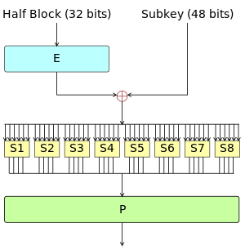

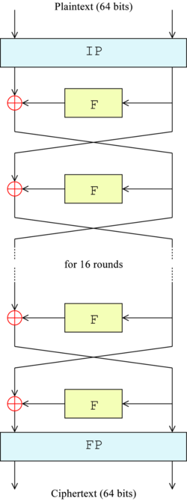

V-Lab Implementation:

Let us work on the simulator. This simulator is performing the 3DES algorithm.

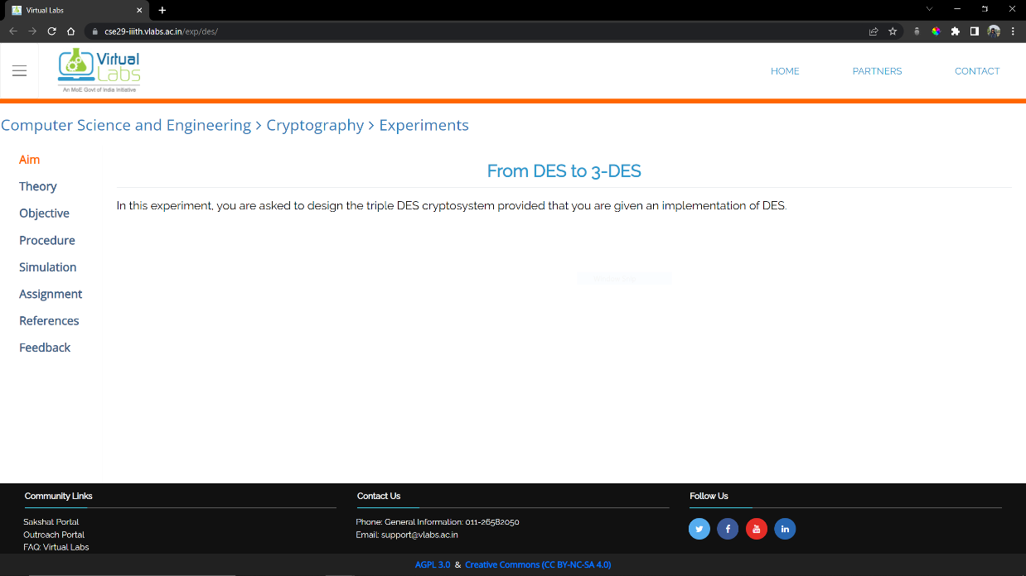

Looking at the theory:

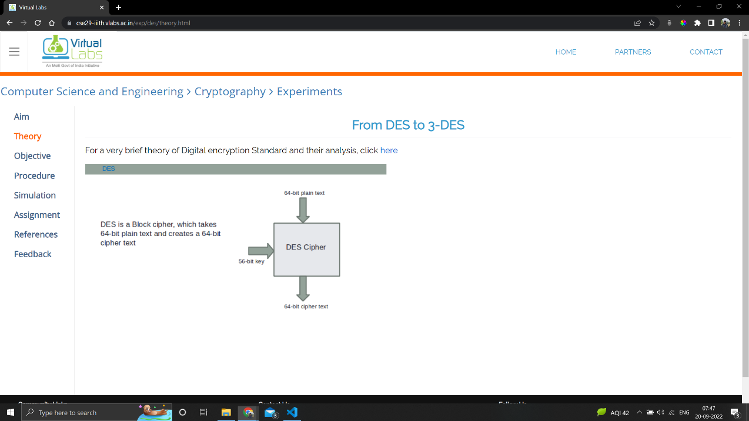

Objective:

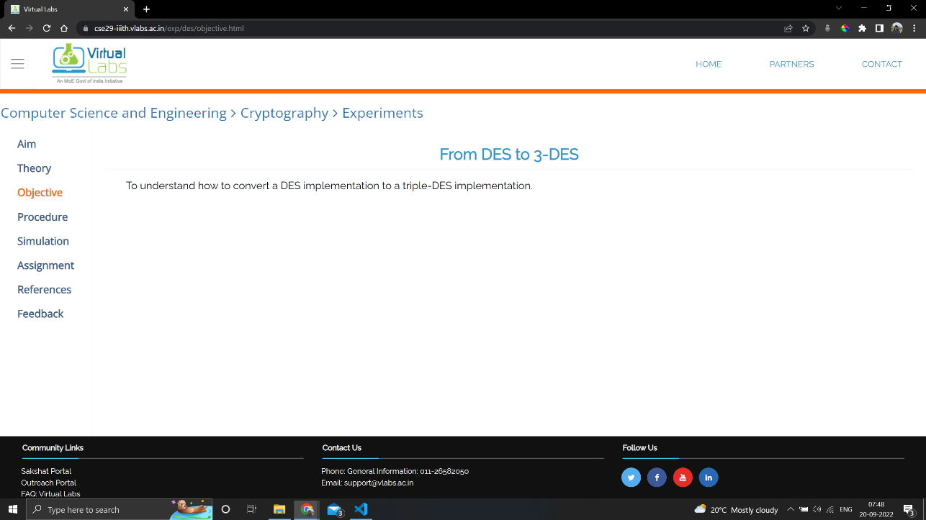

Procedure

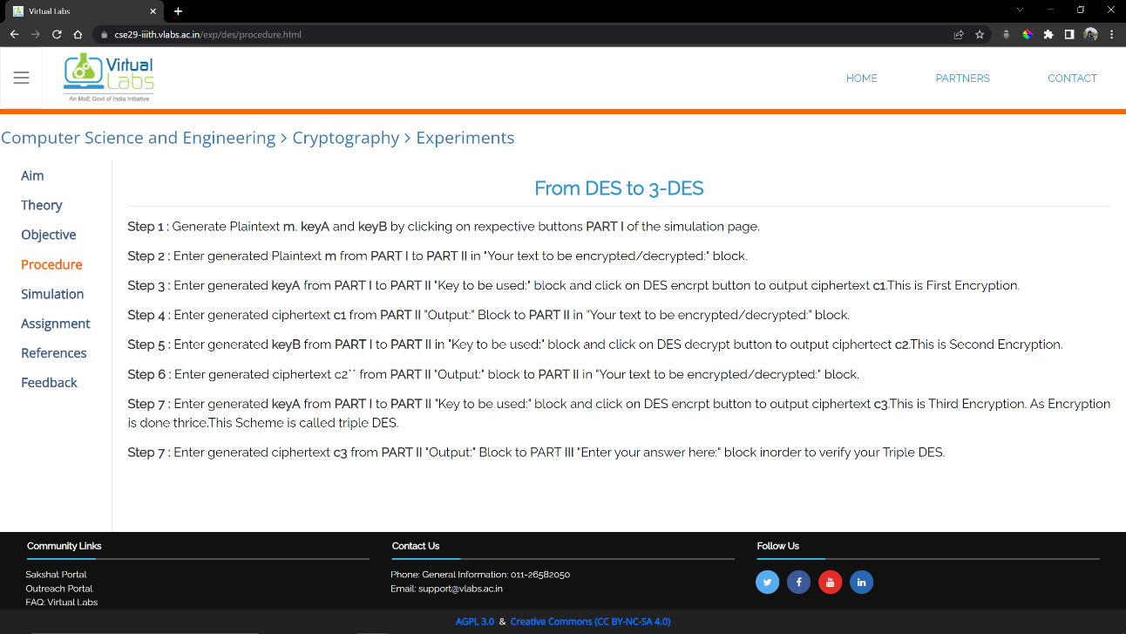

We try entering a value

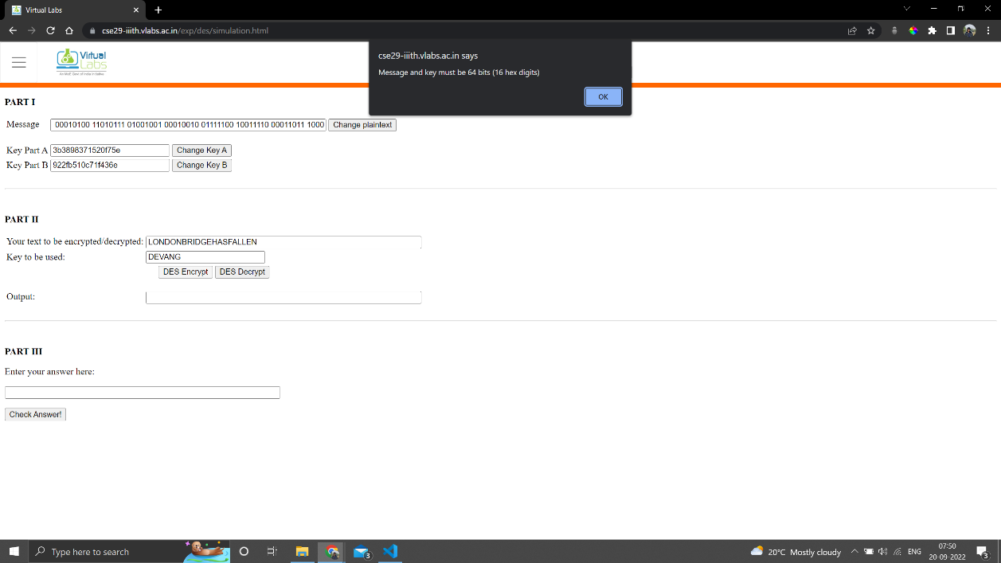

Simple DES

Plaintext: 10000101 01110111 10000111 00110111 11111010 10010011 10011010 1001111

Key: 07cb75d5b5a267fb

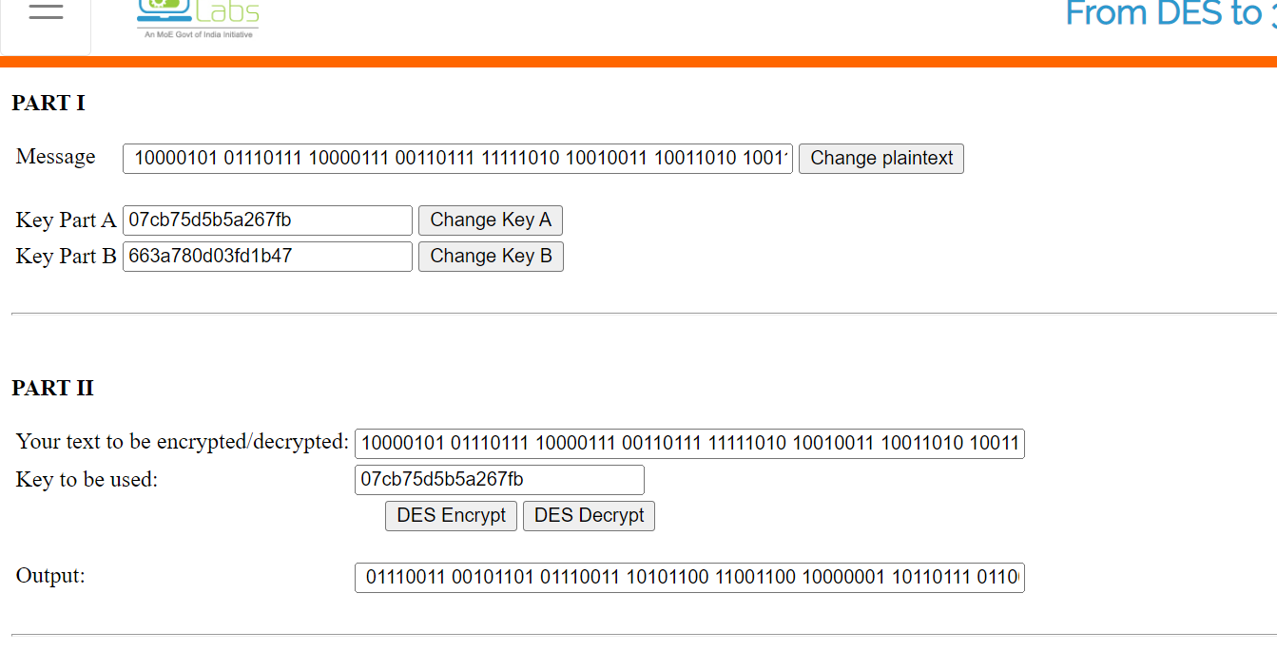

EncText: 01110011 00101101 01110011 10101100 11001100 10000001 10110111 01100010

Decryption

Plaintext: 10000101 01110111 10000111 00110111 11111010 10010011 10011010 10011110

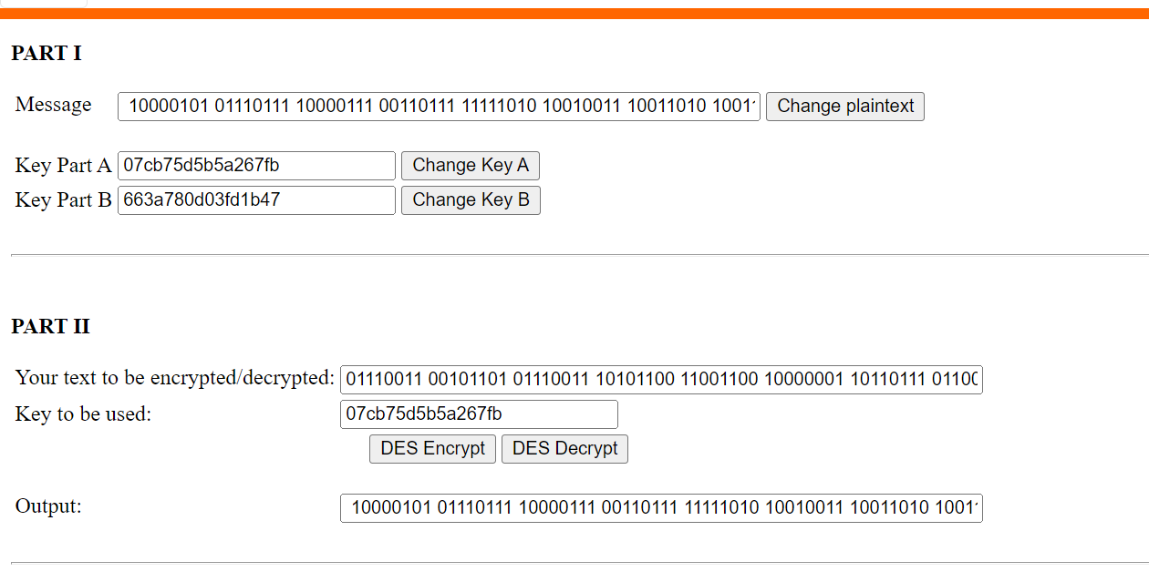

Let's do once from Part 1 values

DES -> 3DES

Plaintext -> 00010100 11010111 01001001 00010010 01111100 10011110 00011011 1000001

Key A -> 3b3898371520f75e

Key B -> 922fb510c71f436e

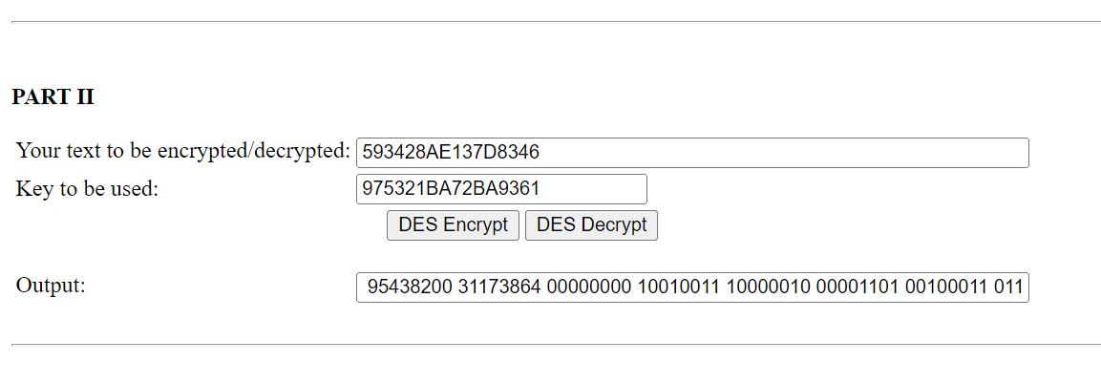

Text - 593428AE137D8346  
Key - 975321BA72BA9361

Encryption: 95438200 31173864 00000000 10010011 10000010 00001101 00100011 01100100

Then we take this encrypted text and encrypt with another key.

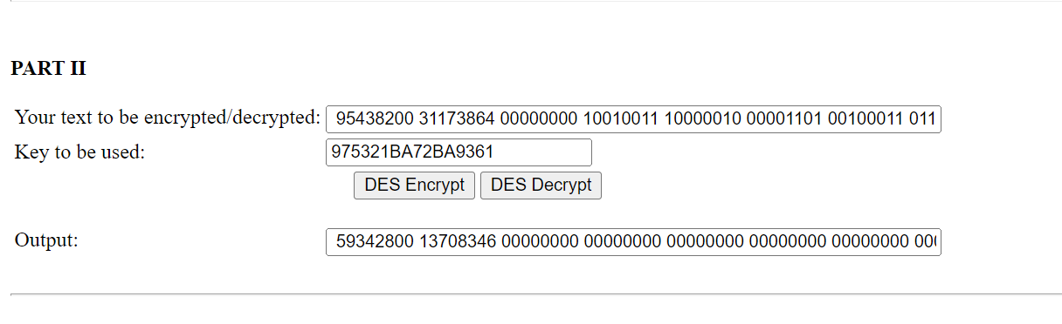

Plaintext -> 00010100 11010111 01001001 00010010 01111100 10011110 00011011 1000001

Key A -> 3b3898371520f75e

Key B -> 922fb510c71f436e

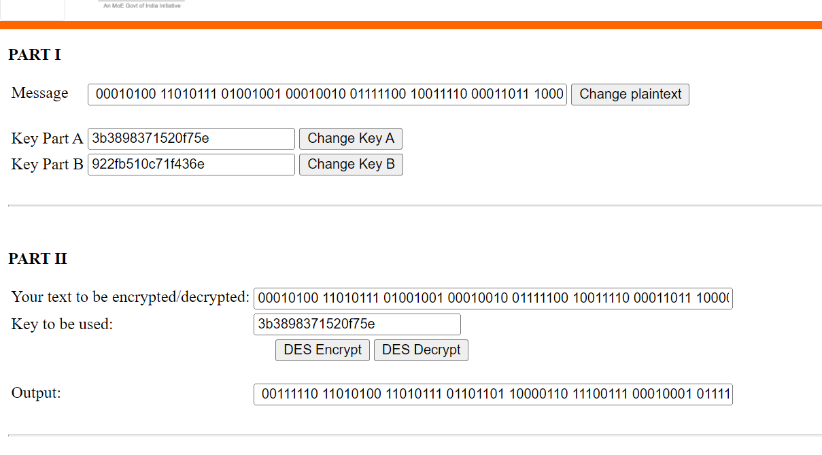

Basically, we need to do this:

Plaintext + KeyA -> C1 Enc

C1 + KeyB -> C2 Dec

C2 + KeyA -> C3 Enc

C3 is the 3 DES Cipher

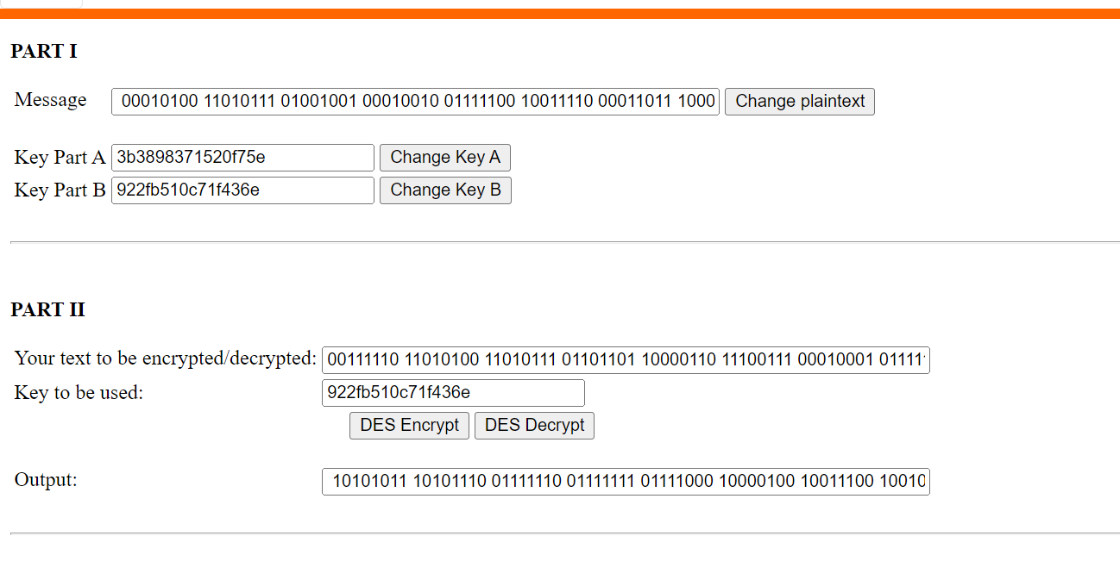

PT + KA -> C1 Enc

00010100 11010111 01001001 00010010 01111100 10011110 00011011 1000001 + 3b3898371520f75e => 00111110 11010100 11010111 01101101 10000110 11100111 00010001 01111101

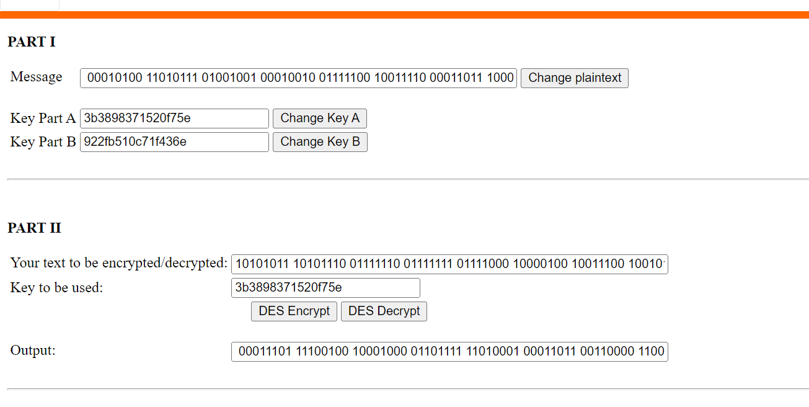

C1 + KB -> C2 Dec

00111110 11010100 11010111 01101101 10000110 11100111 00010001 01111101 + 922fb510c71f436e => 10101011 10101110 01111110 01111111 01111000 10000100 10011100 10010110

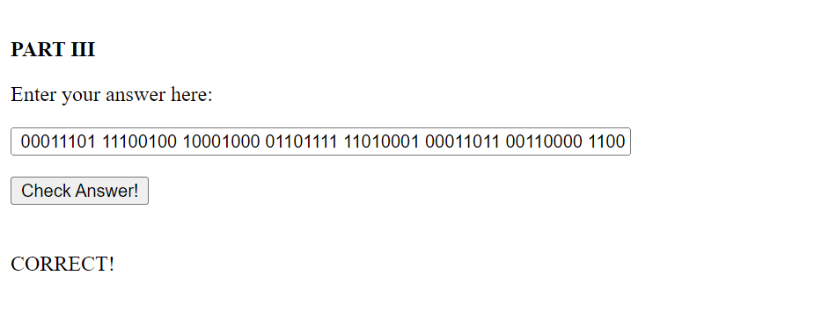

C2 + KA -> C3 Enc

10101011 10101110 01111110 01111111 01111000 10000100 10011100 10010110 + 3b3898371520f75e => 00011101 11100100 10001000 01101111 11010001 00011011 00110000 11000000

Code:

*# The plaintext and ciphertext would be hexadecimal*

*def* hex2bin(s):

    mp = {'0': "0000",

          '1': "0001",

          '2': "0010",

          '3': "0011",

          '4': "0100",

          '5': "0101",

          '6': "0110",

          '7': "0111",

          '8': "1000",

          '9': "1001",

          'A': "1010",

          'B': "1011",

          'C': "1100",

          'D': "1101",

          'E': "1110",

          'F': "1111"}

    bin = ""

*for* i *in* range(len(s)):

        bin = bin + mp[s[i]]

*return* bin

*def* bin2hex(s):

    mp = {"0000": '0',

          "0001": '1',

          "0010": '2',

          "0011": '3',

          "0100": '4',

          "0101": '5',

          "0110": '6',

          "0111": '7',

          "1000": '8',

          "1001": '9',

          "1010": 'A',

          "1011": 'B',

          "1100": 'C',

          "1101": 'D',

          "1110": 'E',

          "1111": 'F'}

    hex = ""

*for* i *in* range(0, len(s), 4):

        ch = ""

        ch = ch + s[i]

        ch = ch + s[i + 1]

        ch = ch + s[i + 2]

        ch = ch + s[i + 3]

        hex = hex + mp[ch]

*return* hex

*# Binary to decimal conversion*

*def* bin2dec(binary):

    decimal, i, n = 0, 0, 0

*while*(binary != 0):

        dec = binary % 10

        decimal = decimal + dec * pow(2, i)

        binary = binary//10

        i += 1

*return* decimal

*# Decimal to binary conversion*

*def* dec2bin(num):

    res = bin(num).replace("0b", "")

*if*(len(res) % 4 != 0):

        div = len(res) / 4

        div = int(div)

        counter = (4 * (div + 1)) - len(res)

*for* i *in* range(0, counter):

            res = '0' + res

*return* res

*# Permute function to rearrange the bits*

*def* permute(k, arr, n):

    permutation = ""

*for* i *in* range(0, n):

        permutation = permutation + k[arr[i] - 1]

*return* permutation

*# shifting the bits towards left by nth shifts*

*def* shift_left(k, nth_shifts):

    s = ""

*for* i *in* range(nth_shifts):

*for* j *in* range(1, len(k)):

            s = s + k[j]

        s = s + k[0]

        k = s

        s = ""

*return* k

*# calculating xow of two strings of binary number a and b*

*def* xor(a, b):

    ans = ""

*for* i *in* range(len(a)):

*if* a[i] == b[i]:

            ans = ans + "0"

*else*:

            ans = ans + "1"

*return* ans

*# Table of Position of 64 bits at initial level: Initial Permutation Table*

initial_perm = [58, 50, 42, 34, 26, 18, 10, 2,

                60, 52, 44, 36, 28, 20, 12, 4,

                62, 54, 46, 38, 30, 22, 14, 6,

                64, 56, 48, 40, 32, 24, 16, 8,

                57, 49, 41, 33, 25, 17, 9, 1,

                59, 51, 43, 35, 27, 19, 11, 3,

                61, 53, 45, 37, 29, 21, 13, 5,

                63, 55, 47, 39, 31, 23, 15, 7]

*# Expansion D-box Table*

exp_d = [32, 1, 2, 3, 4, 5, 4, 5,

         6, 7, 8, 9, 8, 9, 10, 11,

         12, 13, 12, 13, 14, 15, 16, 17,

         16, 17, 18, 19, 20, 21, 20, 21,

         22, 23, 24, 25, 24, 25, 26, 27,

         28, 29, 28, 29, 30, 31, 32, 1]

*# Straight Permutation Table*

per = [16,  7, 20, 21,

       29, 12, 28, 17,

       1, 15, 23, 26,

       5, 18, 31, 10,

       2,  8, 24, 14,

       32, 27,  3,  9,

       19, 13, 30,  6,

       22, 11,  4, 25]

*# S-box Table*

sbox = [[[14, 4, 13, 1, 2, 15, 11, 8, 3, 10, 6, 12, 5, 9, 0, 7],

         [0, 15, 7, 4, 14, 2, 13, 1, 10, 6, 12, 11, 9, 5, 3, 8],

         [4, 1, 14, 8, 13, 6, 2, 11, 15, 12, 9, 7, 3, 10, 5, 0],

         [15, 12, 8, 2, 4, 9, 1, 7, 5, 11, 3, 14, 10, 0, 6, 13]],

        [[15, 1, 8, 14, 6, 11, 3, 4, 9, 7, 2, 13, 12, 0, 5, 10],

         [3, 13, 4, 7, 15, 2, 8, 14, 12, 0, 1, 10, 6, 9, 11, 5],

         [0, 14, 7, 11, 10, 4, 13, 1, 5, 8, 12, 6, 9, 3, 2, 15],

         [13, 8, 10, 1, 3, 15, 4, 2, 11, 6, 7, 12, 0, 5, 14, 9]],

        [[10, 0, 9, 14, 6, 3, 15, 5, 1, 13, 12, 7, 11, 4, 2, 8],

         [13, 7, 0, 9, 3, 4, 6, 10, 2, 8, 5, 14, 12, 11, 15, 1],

         [13, 6, 4, 9, 8, 15, 3, 0, 11, 1, 2, 12, 5, 10, 14, 7],

         [1, 10, 13, 0, 6, 9, 8, 7, 4, 15, 14, 3, 11, 5, 2, 12]],

        [[7, 13, 14, 3, 0, 6, 9, 10, 1, 2, 8, 5, 11, 12, 4, 15],

         [13, 8, 11, 5, 6, 15, 0, 3, 4, 7, 2, 12, 1, 10, 14, 9],

         [10, 6, 9, 0, 12, 11, 7, 13, 15, 1, 3, 14, 5, 2, 8, 4],

         [3, 15, 0, 6, 10, 1, 13, 8, 9, 4, 5, 11, 12, 7, 2, 14]],

        [[2, 12, 4, 1, 7, 10, 11, 6, 8, 5, 3, 15, 13, 0, 14, 9],

         [14, 11, 2, 12, 4, 7, 13, 1, 5, 0, 15, 10, 3, 9, 8, 6],

         [4, 2, 1, 11, 10, 13, 7, 8, 15, 9, 12, 5, 6, 3, 0, 14],

         [11, 8, 12, 7, 1, 14, 2, 13, 6, 15, 0, 9, 10, 4, 5, 3]],

        [[12, 1, 10, 15, 9, 2, 6, 8, 0, 13, 3, 4, 14, 7, 5, 11],

         [10, 15, 4, 2, 7, 12, 9, 5, 6, 1, 13, 14, 0, 11, 3, 8],

         [9, 14, 15, 5, 2, 8, 12, 3, 7, 0, 4, 10, 1, 13, 11, 6],

         [4, 3, 2, 12, 9, 5, 15, 10, 11, 14, 1, 7, 6, 0, 8, 13]],

        [[4, 11, 2, 14, 15, 0, 8, 13, 3, 12, 9, 7, 5, 10, 6, 1],

         [13, 0, 11, 7, 4, 9, 1, 10, 14, 3, 5, 12, 2, 15, 8, 6],

         [1, 4, 11, 13, 12, 3, 7, 14, 10, 15, 6, 8, 0, 5, 9, 2],

         [6, 11, 13, 8, 1, 4, 10, 7, 9, 5, 0, 15, 14, 2, 3, 12]],

        [[13, 2, 8, 4, 6, 15, 11, 1, 10, 9, 3, 14, 5, 0, 12, 7],

         [1, 15, 13, 8, 10, 3, 7, 4, 12, 5, 6, 11, 0, 14, 9, 2],

         [7, 11, 4, 1, 9, 12, 14, 2, 0, 6, 10, 13, 15, 3, 5, 8],

         [2, 1, 14, 7, 4, 10, 8, 13, 15, 12, 9, 0, 3, 5, 6, 11]]]

*# Final Permutation Table*

final_perm = [40, 8, 48, 16, 56, 24, 64, 32,

              39, 7, 47, 15, 55, 23, 63, 31,

              38, 6, 46, 14, 54, 22, 62, 30,

              37, 5, 45, 13, 53, 21, 61, 29,

              36, 4, 44, 12, 52, 20, 60, 28,

              35, 3, 43, 11, 51, 19, 59, 27,

              34, 2, 42, 10, 50, 18, 58, 26,

              33, 1, 41, 9, 49, 17, 57, 25]

*# --parity bit drop table*

keyp = [57, 49, 41, 33, 25, 17, 9,

        1, 58, 50, 42, 34, 26, 18,

        10, 2, 59, 51, 43, 35, 27,

        19, 11, 3, 60, 52, 44, 36,

        63, 55, 47, 39, 31, 23, 15,

        7, 62, 54, 46, 38, 30, 22,

        14, 6, 61, 53, 45, 37, 29,

        21, 13, 5, 28, 20, 12, 4]

*# Number of bit shifts*

shift_table = [1, 1, 2, 2,

               2, 2, 2, 2,

               1, 2, 2, 2,

               2, 2, 2, 1]

*# Key- Compression Table : Compression of key from 56 bits to 48 bits*

key_comp = [14, 17, 11, 24, 1, 5,

            3, 28, 15, 6, 21, 10,

            23, 19, 12, 4, 26, 8,

            16, 7, 27, 20, 13, 2,

            41, 52, 31, 37, 47, 55,

            30, 40, 51, 45, 33, 48,

            44, 49, 39, 56, 34, 53,

            46, 42, 50, 36, 29, 32]

*def* encrypt(pt, rkb, rk):

    pt = hex2bin(pt)

*# Initial Permutation*

    pt = permute(pt, initial_perm, 64)

    print("After initial permutation", bin2hex(pt))

*# Splitting*

    left = pt[0:32]

    right = pt[32:64]

*for* i *in* range(0, 16):

*#  Expansion D-box: Expanding the 32 bits data into 48 bits*

        right_expanded = permute(right, exp_d, 48)

*# XOR RoundKey[i] and right_expanded*

        xor_x = xor(right_expanded, rkb[i])

*# S-boxex: substituting the value from s-box table by calculating row and column*

        sbox_str = ""

*for* j *in* range(0, 8):

            row = bin2dec(int(xor_x[j * 6] + xor_x[j * 6 + 5]))

            col = bin2dec(

                int(xor_x[j * 6 + 1] + xor_x[j * 6 + 2] + xor_x[j * 6 + 3] + xor_x[j * 6 + 4]))

            val = sbox[j][row][col]

            sbox_str = sbox_str + dec2bin(val)

*# Straight D-box: After substituting rearranging the bits*

        sbox_str = permute(sbox_str, per, 32)

*# XOR left and sbox_str*

        result = xor(left, sbox_str)

        left = result

*# Swapper*

*if*(i != 15):

            left, right = right, left

        print("Round ", i + 1, " ", bin2hex(left),

              " ", bin2hex(right), " ", rk[i])

*# Combination*

    combine = left + right

*# Final permutation: final rearranging of bits to get cipher text*

    cipher_text = permute(combine, final_perm, 64)

*return* cipher_text

*# 64bit PT and 64bit Key*

print("DES Algorithm")

print("What do you wish to do?")

print("1. Encrypt")

print("2. Decrypt\n")

n = int(input())

*if* n == 1:

    print("Enter Plaintext: ", end='')

    plaintext = input()

    print("Enter Key: ", end='')

    key = input()

    key = hex2bin(key)

*# Splitting*

    left = key[0:28]    *# rkb for RoundKeys in binary*

    right = key[28:56]  *# rk for RoundKeys in hexadecimal*

    rkb = []

    rk = []

*for* i *in* range(0, 16):

*# Shifting the bits by nth shifts by checking from shift table*

        left = shift_left(left, shift_table[i])

        right = shift_left(right, shift_table[i])

*# Combination of left and right string*

        combine_str = left + right

*# Compression of key from 56 to 48 bits*

        round_key = permute(combine_str, key_comp, 48)

        rkb.append(round_key)

        rk.append(bin2hex(round_key))

    cipher_text = bin2hex(encrypt(plaintext, rkb, rk))

    print("Cipher Text : ", cipher_text)

*else*:

    print("Enter Ciphertext: ", end='')

    ciphertext = input()

    print("Enter Key: ", end='')

    key = input()

    key = hex2bin(key)

*# Splitting*

    left = key[0:28]    *# rkb for RoundKeys in binary*

    right = key[28:56]  *# rk for RoundKeys in hexadecimal*

    rkb = []

    rk = []

*for* i *in* range(0, 16):

*# Shifting the bits by nth shifts by checking from shift table*

        left = shift_left(left, shift_table[i])

        right = shift_left(right, shift_table[i])

*# Combination of left and right string*

        combine_str = left + right

*# Compression of key from 56 to 48 bits*

        round_key = permute(combine_str, key_comp, 48)

        rkb.append(round_key)

        rk.append(bin2hex(round_key))

    rkb_rev = rkb[::-1]

    rk_rev = rk[::-1]

    text = bin2hex(encrypt(ciphertext, rkb_rev, rk_rev))

    print("Plaintext: ", text)

We now solve some examples with the code.

Say we wish to encrypt: ‘123456ABCD132536’  
and we take our key as ‘AABB09182736CCDD’

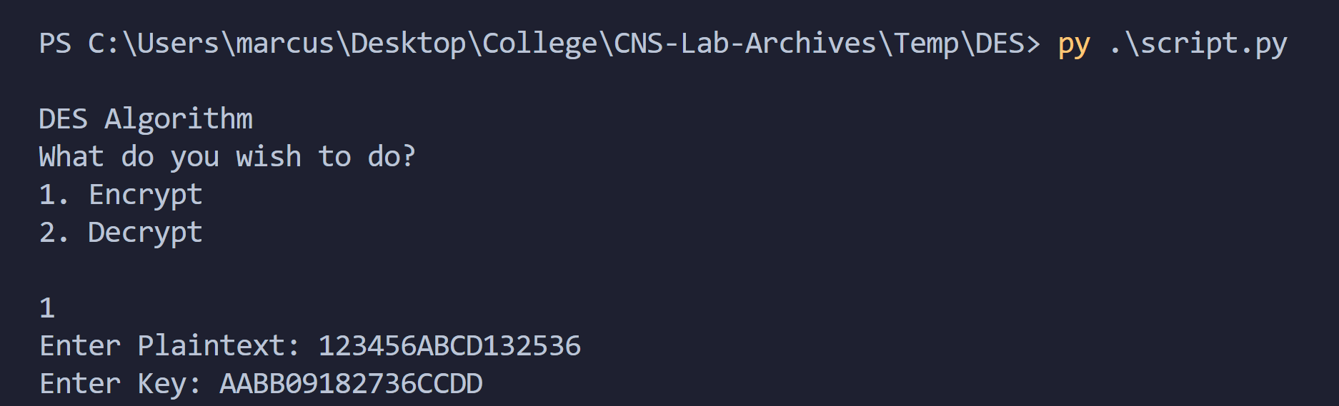

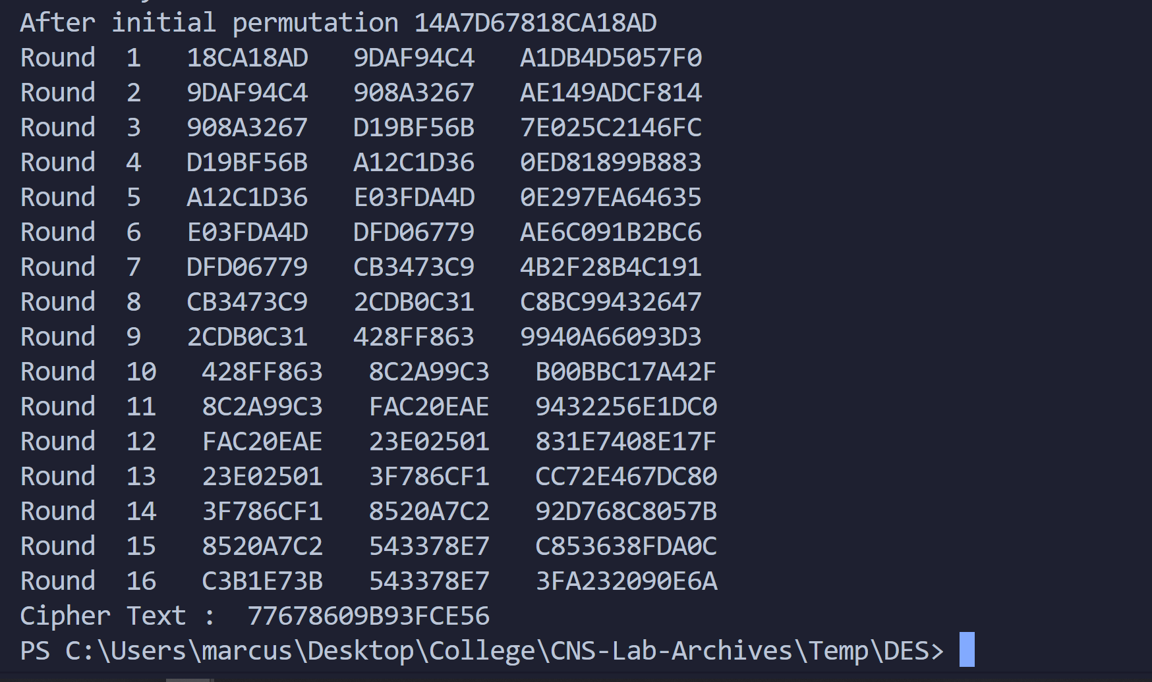

We now decipher:

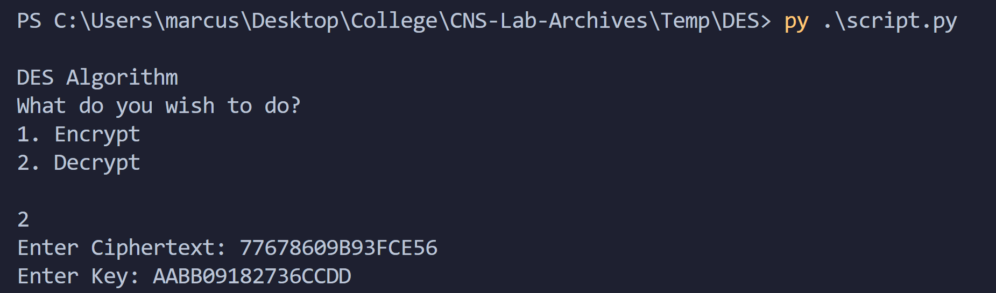

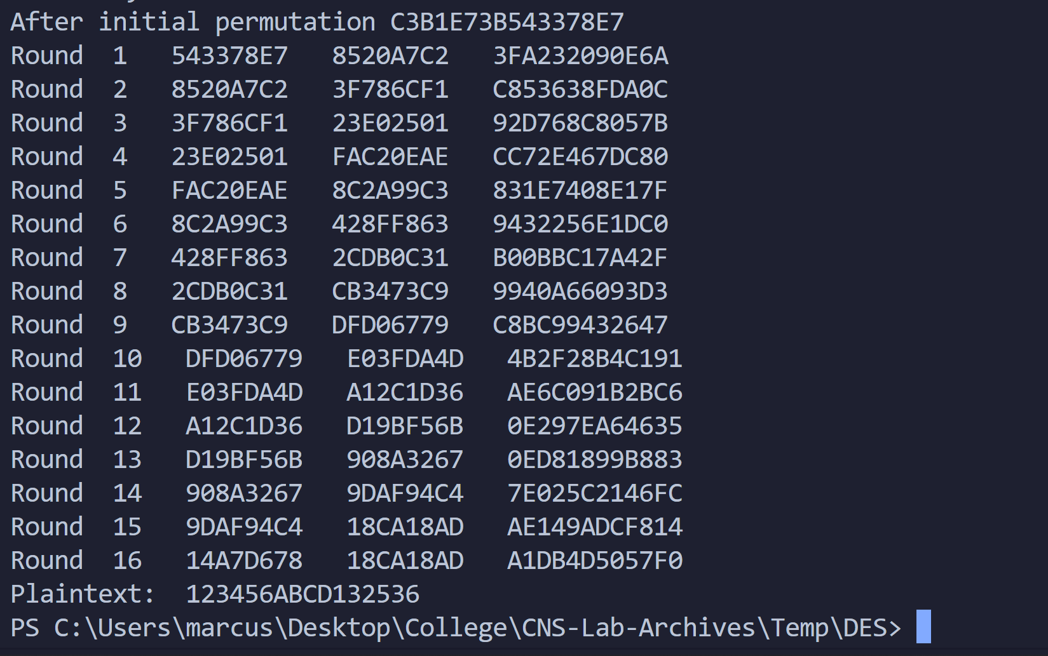

Therefore, we get our plaintext back.

Let’s take another example:

Say we wish to encrypt: ‘9307805348ABCDEF’  
and we take our key as ‘1234567890ABCDEF’

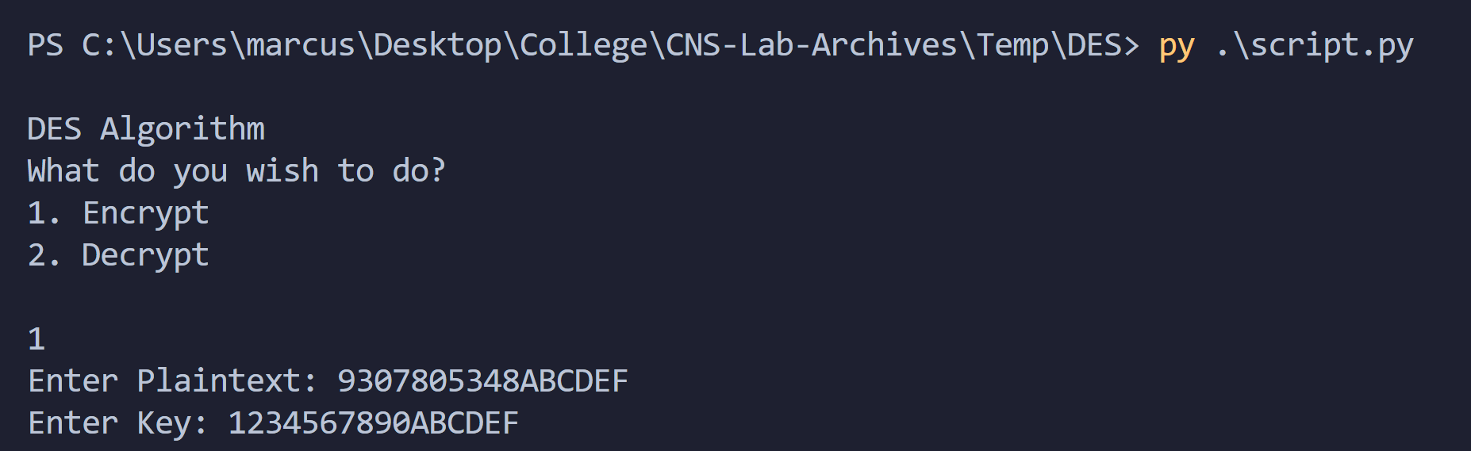

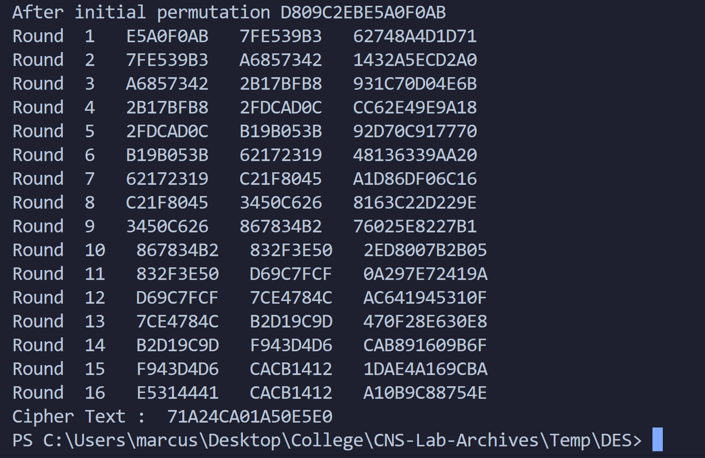

We now decipher:

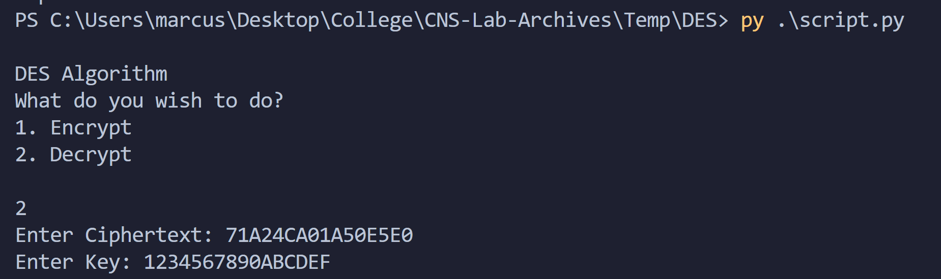

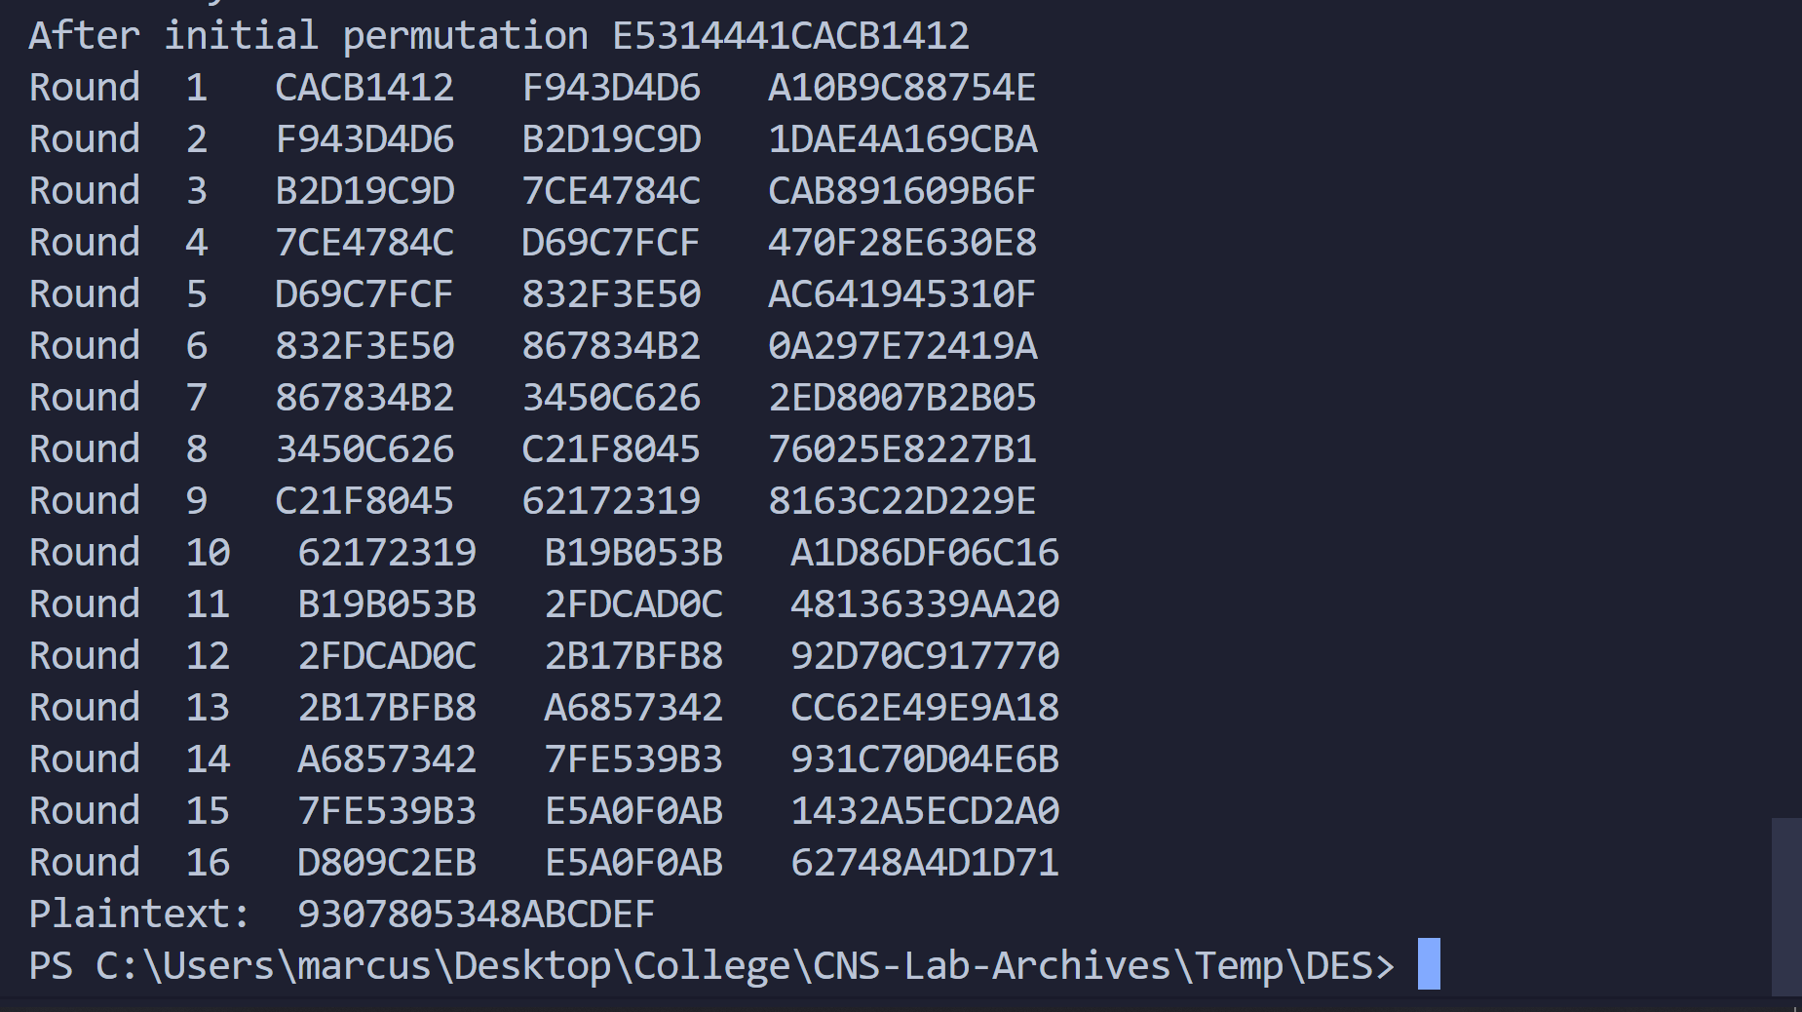

We get the plaintext back.

Thus, we demonstrated the working of the code with examples.

Conclusion:

Thus, the Data Encryption Standard (DES) algorithm was studied and demonstrated with the code.